Instructions
- Proforma 1 to 9 for Actuarial Valuation as at 31.03.2016.xls is Macro-enabled, on opening the file, the user will be prompted as follows:
Option……..
Security Warning Macros have been disabled

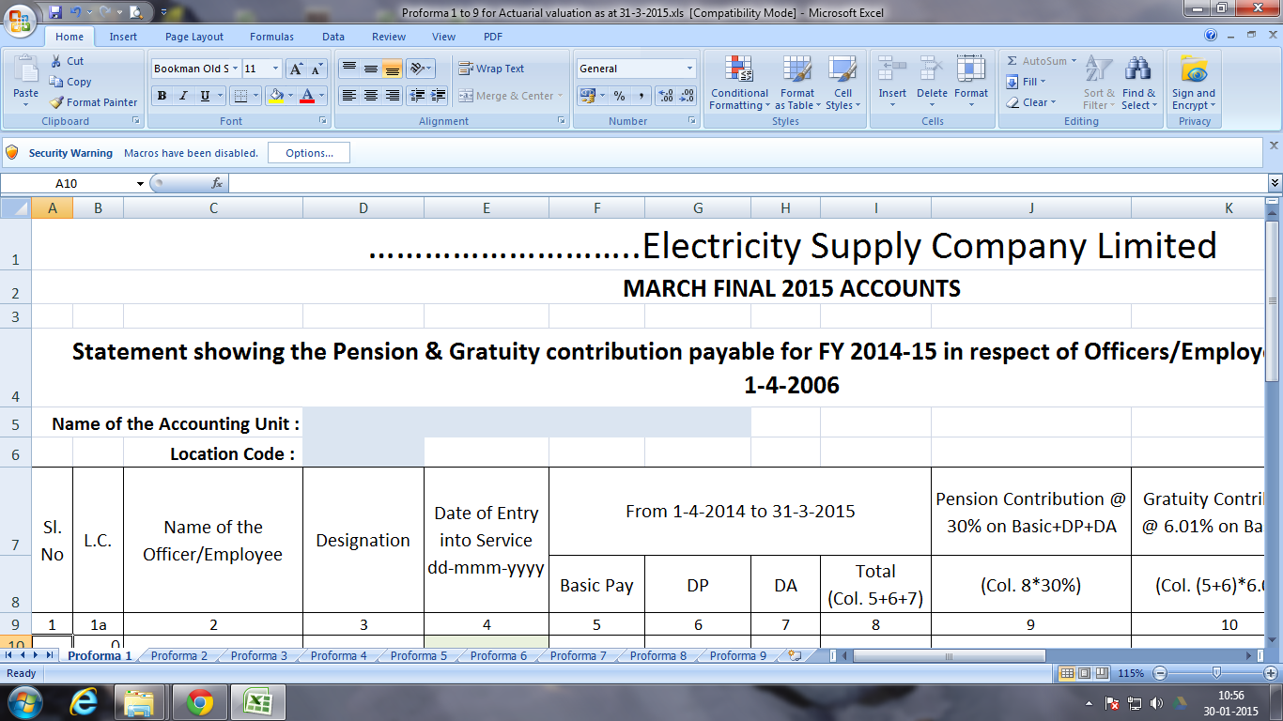

- Each time the user opens the file, he has to click the options and then Enable Macros by clicking Enable Content.
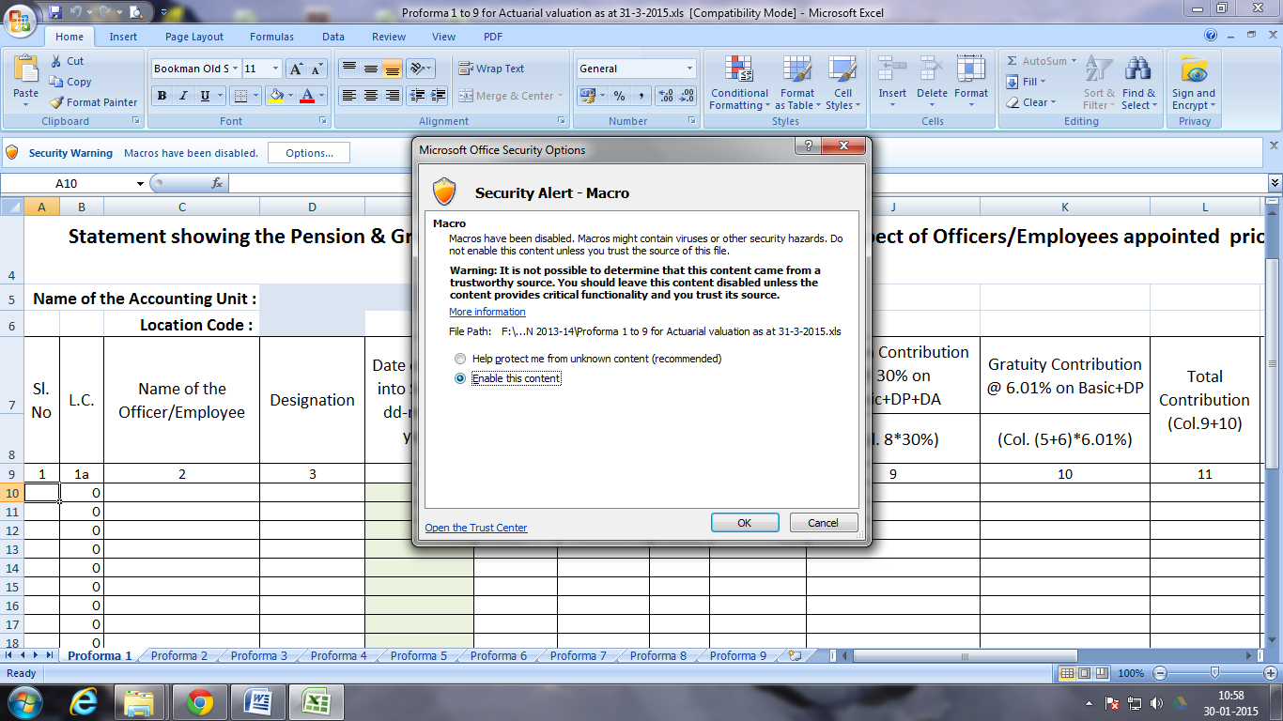
- There is a button “INSERT ROWS” on all the sheets (Proforma 1 to 9). The user will have to enter the number of rows required in Cell YELLOW COLOURED in the respective pages and click on the INSERT ROWS button.

